2023 Noble County Regional Planning Commission
Members
Dates Note Individual Term Expirations
VOTING MEMBERS:
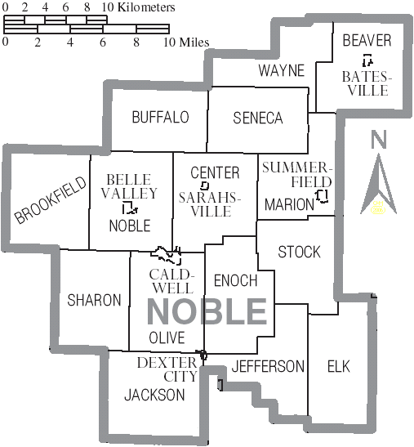
District 1 – Wayne, Beaver, Seneca and Marion Townships
David Sayre 12-2022
Merlin Wentworth 12-2025
District 2 – Buffalo, Brookfield, Noble and Center Townships
Milton Lisak 12-2025
Allen Fraley 12-2023
District 3 – Sharon, Olive, and Jackson Townships
Kirby Moore 12-2024
Open
District 4 – Enoch, Stock, Jefferson and Elk Townships
Vernon Thomas 12-2024
Claire Shockling 12-2023
Village of Caldwell
Ryan Singer 12-2022
Jeff Minosky 12-2024
Departments
Jay McElroy – NRCS/Natural Resources Conservation Service (Noble)
Shawn Ray – Noble Co. Health Department
Gwynn Stewart – Ohio State University Extension Noble County
At Large
Brooke Campbell 12-2025
Chasity Schmelzenbach 12-2024
JoAnn Steed 12-2023
Jim Warren 12-2025
EX-OFFICIO / NON-VOTING MEMBERS
Noble County Commissioners Ty Moore; Allen Fraley & Gary Saling
Noble County Engineer Todd Coss
Noble County Prosecutor Jordan Croucher
Noble County Auditor Peggy Davis
Noble Local Schools Superintendent Dan Leffingwell
Caldwell Schools Superintendent Greg Gifford
Noble County Sheriff Jason Mackie
2022 Officers
Jim Warren – Chairperson
Allen Fraley – Vice Chairperson
Gwynn Stewart – Secretary (Roster updated - Revised 1/5/2023)

